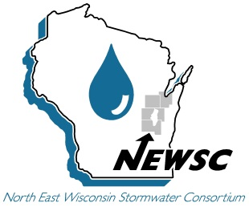 | Comments to WDNR  Establishment of Protective Areas for Wetlands Guidance  NEWSC Rules & Regulations Committee  February 4, 2015

February 10, 2015
Please consider the comments below developed by the members of the Northeast Wisconsin Stormwater Consortium when finalizing the proposed Establishment of Protective Areas for Wetlands Guidance.

- Less Susceptible (page 4) – Please modify the fourth sentence of the first paragraph as follows: “A wetland is considered to be dominated by invasive species if it currently contains more than 50 percent invasive species, as measured by absolute vegetative cover.” By definition, a dominant species has a controlling influence or defines the character of a wetland community according to US Army Corps of Engineers Wetland Delineation Manual, 1987. 50 percent is a significant majority and reasonably fits the definition of “dominated”. Without active eradication or control, a wetland with more than 50 percent invasive species is likely to further degrade in the future via the spread of invasive species such as reed canary grass, purple loosestrife, phragmites, and narrow−leaf cattail (refer to list of other potential invasive species within NR 40). A wider protective area is not anticipated to control or reduce the spread of invasive species within an unmanaged wetland. NR 151 does not require that invasive species be eradicated or managed within a wetland.

Please cite the scientific data relied upon by DNR to establish the 90 percent value identified in the guidance document. NR 151 is a water quality regulation, not an invasive species or a wetland regulation.

A wetland located adjacent to a significant river or stream is likely more influenced by the water quality within the river or stream than from the adjacent post-construction site (please refer to Attachment 2 of the guidance document). In these instances, a wider wetland protective area is impacting the landowner of the post-construction site, rather than targeting pollutant sources located upriver / upstream of the post-construction site. The permittee of a new development post-construction site is already providing an 80 percent TSS reduction. The permittee of a re-development post-construction site is exempt from the protective area performance standards.

- Determining the Wetland Protective Area (page 5) – Please modify the fourth sentence of the first paragraph as follows: “When two or more wetland susceptibility classifications are identified within the same contiguous wetland boundary, the final protective area boundary is to be delineated using the outermost boundary of each protective area category (i.e. highly susceptible wetland, less susceptible wetland, USGS stream, ORW/ERW, etc.).” For clarification, please create a figure that depicts all three wetland susceptibility classifications within the same contiguous wetland boundary and then depict the respective protective area widths, including the governing outermost protective area boundary.

The statement that “the more/most susceptible type of wetland is used to determine the protective area” runs counter to the purpose of providing varying protective area widths for three different wetland susceptibility classifications in NR 151. An approach similar to Step 2 on page 5 of this guidance document is suggested. Consider the following example:

- A coniferous swamp (high susceptibility) is located at the center of a wetland boundary. The coniferous swamp (high susceptibility) is completely surrounded by a 500 foot wide reed canary grass wetland (low susceptibility).
- In our opinion, it is not justifiable from a water quality or ecological perspective to require a 75 foot protective area starting at the outer edge of the reed canary grass wetland (low susceptibility) since the edge of the coniferous swamp is located 500 feet from the outermost edge of the reed canary grass marsh. In essence, the high susceptibility wetland is buffered by the low susceptibility wetland. In this example, the outermost protective area boundary for this wetland should be 30 feet, not 75 feet.

- Determining the Wetland Protective Area, Highly Susceptible (page 5 & 6) – Please modify the last sentence of items b, d, e, and f as follows: “Invasive species make up less than 10 percent of the plant community’s composition.”

- Determining the Wetland Protective Area, Less Susceptible (page 6) – Please modify the first sentence of the first paragraph as follows: “Less susceptible wetlands are those which consist of invasive species that make up more than 50 percent of the absolute vegetative cover.”

- Determining the Wetland Protective Area (page 6 and 7) – Please delete the entire paragraph that begins at the bottom of page 6 and continues onto the top of page 7. At a minimum, please delete the following sentence: “The wetland should be classified on the basis of the plant community that would normally be supported in the absence of the disturbance.” NR 151.125(1)(f) clearly states that cultivated hydric soils are classified as “less susceptible”, not as “the plant community that would normally be supported in the absence of the disturbance.”

- Determining the Wetland Protective Area (page 7) – Please delete the following sentence: “For artificial wetlands, the degree of susceptibility is determined by the plant community composition.” Wet detention ponds and dry detention ponds can contain artificial wetlands, but are exempt from NR 103 regulations. The intent of NR 151.125 is not to delineate protective areas for artificial wetlands located within a wet detention pond, dry detention pond, or other artificial wetland. Recently, WDNR has classified a few artificial wetlands located within dry detention ponds as regulated wetlands when NR 103 clearly exempts these facilities. Please clarify in the guidance if a wetland located within a dry detention pond, wet detention pond, or other stormwater facility that was constructed for flood control or water quality purposes is a regulated wetland that is subject to the NR 151 protective area performance standards. Please add the following sentence to the guidance document: “Pursuant to NR 103, wetlands that are located within a privately-owned or publicly-owned stormwater management facility (e.g. wet detention ponds, dry detention ponds, etc.) are not regulated by the WDNR and consequently are not subject to the protective area performance standards.”

Please contact us with any questions regarding our comments.
Sincerely,
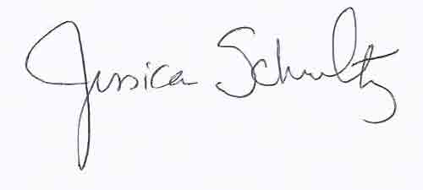
Jessica Schultz
Director
(920)858-4246
newsc@newsc.org
NEWSC Member Communities
Brown County  Calumet County  Fond du Lac County  Outagamie County  Winnebago County  UW Oshkosh | City of Appleton  City of DePere  City of Fond du Lac  City of Green Bay  City of Kaukauna  City of Manitowoc  City of Marinette  City of Menasha  City of Neenah  City of Oshkosh  City of Two Rivers | Town of Black Wolf  Town of Buchanan  Town of Fond du Lac  Town of Friendship  Town of Grand Chute  Town of Greenville  Town of Ledgeview  Town of Menasha  Town of Neenah  Town of Scott  Town of Taycheedah | Village of Allouez  Village of Ashwaubenon  Village of Bellvue  Village of Combined Locks  Village of Harrison  Village of Hobart  Village of Howard  Village of Kimberly  Village of Little Chute  Village of North Fond du Lac  Village of Sherwood  Village of Suamico

