 | Comments to WDNR  Erosion Control Note Guidance  NEWSC Rules & Regulations Committee  February 4, 2015

February 10, 2015
Please consider the comments below developed by the members of the Northeast Wisconsin Stormwater Consortium when finalizing the proposed Erosion Control Notes.
- Please add the following sentence to the guidance document: “The following erosion control notes are merely examples. This guidance document does not require permit applicants to use these notes on their erosion control plans.”

- Please replace the phase “rock construction entrance” with the phrase “tracking pad” throughout the guidance document.

- Note 6 (page 2) – Please delete the phase “on slopes of 20% or more”. Also, the word “construction” is misspelled.

- Note 13 (page 3) – Please also reference the Sediment Trap Technical Standard.

- Note 20 (page 3) – Please add the following phrase to the end of the sentence “of topsoil placement”.

Please contact us with any questions regarding our comments.
Sincerely,
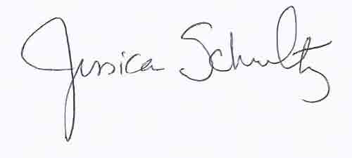
Jessica Schultz
Director
(920)858-4246
newsc@newsc.org
NEWSC Member Communities
Brown County  Calumet County  Fond du Lac County  Outagamie County  Winnebago County  UW Oshkosh | City of Appleton  City of DePere  City of Fond du Lac  City of Green Bay  City of Kaukauna  City of Manitowoc  City of Marinette  City of Menasha  City of Neenah  City of Oshkosh  City of Two Rivers | Town of Black Wolf  Town of Buchanan  Town of Fond du Lac  Town of Friendship  Town of Grand Chute  Town of Greenville  Town of Ledgeview  Town of Menasha  Town of Neenah  Town of Scott  Town of Taycheedah | Village of Allouez  Village of Ashwaubenon  Village of Bellvue  Village of Combined Locks  Village of Harrison  Village of Hobart  Village of Howard  Village of Kimberly  Village of Little Chute  Village of North Fond du Lac  Village of Sherwood  Village of Suamico

